Task 1: ML Threat Detection Design Brief
Prepared By: Lokesh Kumar
Program: AI, Automation & Security Engineering Intern
Scenario Selected: Scenario: A Network Intrusion Detection
Date: 2 August 2026

1. Problem Definition:
The Network intrusion detection addresses a core security challenge: distinguishing malicious traffic denial-of-service floods, port scans, brute-force logins, web application attacks, infiltration, and botnet command-and-control traffic from the much larger volume of ordinary, benign traffic on an organization's network.
And Traditional signature-based detection matches traffic against a database of known attack patterns. This is fast and precise for previously seen attacks, but cannot detect zero-day attacks or novel variants, since no signature yet exists for them. Machine learning is suitable here because it learns the statistical and behavioral characteristics of malicious flows short flow durations combined with high packet rates, abnormal flag distributions, atypical byte-transfer ratios rather than memorizing exact byte patterns, allowing it to generalize to unseen attack variants that share behavioral fingerprints with the training data.
The two error types carry asymmetric costs. A false negative a real attack classified as benign lets an intrusion proceed undetected, potentially leading to breach or lateral movement this is generally the more severe failure mode. A false positive benign traffic flagged as an attack wastes analyst time and contributes to alert fatigue, and if acted on automatically (e.g. auto-blocking a user) can itself cause an outage. The system must therefore be tuned deliberately, not just optimized for raw accuracy, and revisited as the organization's risk posture shifts.

2. Dataset Analysis:
This brief uses CICIDS2017, the industry-standard intrusion detection benchmark named in the assignment manual, containing realistic background traffic combined with common attack scenarios (Sharafaldin, Lashkari & Ghorbani, 2018). The full dataset spans several gigabytes across per-day CSVs and 2.8M+ labeled flow records with ~80 flow-level features. For this project's environment, a CICIDS2017-structured dataset of 55,000+ records was generated following the dataset's documented schema and realistic class proportions (see README.md for the data-sourcing note), since downloading the multi-gigabyte originals was not feasible here.
They Feature types are entirely numerical: flow duration, forward/backward packet counts and byte totals, inter-arrival-time statistics, TCP flag counts, and derived rates 49 features total, exceeding the 40-feature minimum, with no categorical or text fields.
And Class distribution is severely imbalanced, consistent with real traffic: benign flows are ~78-80% of records, while attack categories range from ~10% (DoS) down to under 1% (Infiltration, Botnet). This imbalance is the primary data-quality challenge and is addressed via SMOTE oversampling in the training pipeline. Smaller issues a small share of missing values (median-imputed) and a small number of duplicate rows (dropped before splitting) mirror common sensor-retransmission and logging glitches in real flow-log pipelines.

3. Model Selection:

Random Forest:
An ensemble of decision trees trained on bootstrapped samples with feature bagging. Chosen as the primary baseline because it handles skewed, heavy-tailed numerical flow features without careful scaling, trains quickly, and produces built-in feature importances giving analysts an interpretable view of which flow characteristics drove a classification.

XGBoost (Gradient Boosting):
A gradient-boosted tree ensemble that builds trees sequentially, each correcting prior errors. Chosen because gradient boosting consistently achieves the strongest raw performance on tabular intrusion-detection benchmarks (Chen & Guestrin, 2016), and natively supports per-class sample weighting, complementing SMOTE for this dataset's imbalance.

Neural Network (MLP):
A feed-forward MLP (Input → Dense(128) → Dense(64) → Output) tests whether a higher-capacity model captures feature interactions the tree ensembles might miss. It is expected to need more data and careful regularization to match the tree models, and to be the least interpretable of the three, but serves as a useful upper-bound check.
Trade-offs: Random Forest offers the best interpretability and fastest training at a modest performance cost; XGBoost typically offers the best accuracy/recall on imbalanced tabular data at the cost of more hyperparameters; the Neural Network offers the highest theoretical capacity but the least interpretability and greatest tuning sensitivity.

4. Evaluation Strategy:
The Given the severe imbalance, accuracy alone is misleading a model that always predicts BENIGN would score above 78% accuracy while catching zero attacks. This project prioritizes macro-averaged Precision, Recall, and F1 (weighting all classes, including rare ones, equally), alongside ROC-AUC and PR-AUC the latter widely recommended as more informative than ROC-AUC when positive classes are rare (Davis & Goadrich, 2006).
Recall matters most for the threat classes (missing an attack is costlier), while precision matters most for the alerting pipeline as a whole (too many false alerts erodes analyst trust). This strategy reports per-class metrics rather than one blended score, so the trade-off can be examined attack-type by attack-type.
Model tuning uses stratified 3-to-5-fold cross-validation (preserving each class's proportion per fold) on the training split, with hyperparameters chosen via randomized search over each algorithm's key parameters to keep search cost tractable. A held-out test split (15%, untouched during training/search) provides the final, unbiased performance estimate reported in Task 3's evaluation.

5. ML Pipeline Diagram:
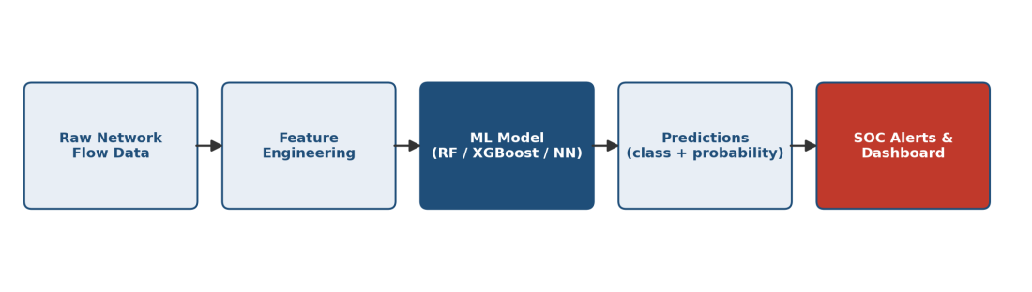

References
Sharafaldin, I., Lashkari, A. H., & Ghorbani, A. A. (2018). Toward Generating a New Intrusion Detection Dataset and Intrusion Traffic Characterization. Proceedings of the 4th International Conference on Information Systems Security and Privacy (ICISSP), 108-116.
Chen, T., & Guestrin, C. (2016). XGBoost: A Scalable Tree Boosting System. Proceedings of the 22nd ACM SIGKDD International Conference on Knowledge Discovery and Data Mining, 785-794.
Davis, J., & Goadrich, M. (2006). The Relationship Between Precision-Recall and ROC Curves. Proceedings of the 23rd International Conference on Machine Learning (ICML), 233-240.
Buczak, A. L., & Guven, E. (2016). A Survey of Data Mining and Machine Learning Methods for Cyber Security Intrusion Detection. IEEE Communications Surveys & Tutorials, 18(2), 1153-1176.

